PROJECT DOCUMENTATION
Artificial Intelligence
Role of AI in Automated Network Request Management
PROJECT
Automated Network Request Management
Date
Team ID
Project Name | Automated Network Request Management
Maximum Marks

1. Introduction
Automating network request management in ServiceNow enhances operational efficiency by streamlining workflows, reducing manual interventions, and ensuring real-time updates. This document describes how Artificial Intelligence (AI) capabilities are applied within the project to build a fully automated and scalable network change management process — enabling rapid fulfillment, audit-ready change records, and accurate configuration tracking for user-initiated network requests.
AI is embedded at the intake, classification, and decision-support stages of the workflow so that requests move from submission to fulfillment with minimal human touch, while still preserving full traceability for audit purposes.

2. Objective of AI in the Project
- Understand network requests submitted in natural language and convert them into structured, actionable data.
- Automatically classify, prioritize, and route requests to the correct fulfillment workflow.
- Reduce manual triage effort by the network operations team.
- Detect anomalies in configuration items (CIs) and flag high-risk changes before they are auto-approved.
- Provide conversational, self-service status updates to requesters.

3. AI-Augmented Architecture
The diagram below illustrates how AI components are positioned between the requester and the automated ServiceNow change workflow. The ServiceNow Virtual Agent handles natural-language intake, while the Predictive Intelligence engine performs classification, prioritization, and CI-related anomaly detection before handing off to Flow Designer for execution.
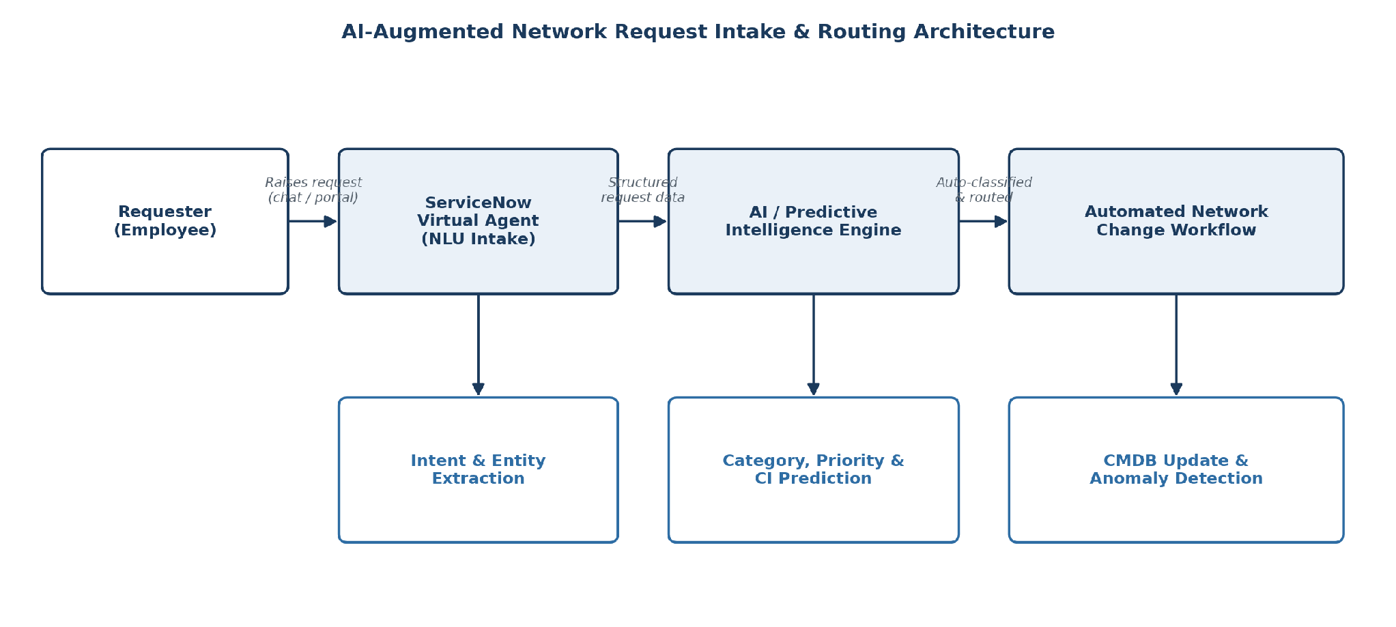
Figure 1: AI-augmented network request intake and routing architecture

4. Key AI Capabilities Used

4.1 Natural Language Understanding (NLU) Intake
The ServiceNow Virtual Agent uses NLU to interpret free-text or conversational requests (e.g., "I need a new firewall rule opened for our branch office") and extract intent and entities such as request type, location, and urgency, removing the need for users to navigate complex forms.

4.2 Predictive Intelligence for Classification
Historical ticket data trains a predictive classification model that automatically assigns category, subcategory, and priority to incoming requests, reducing dependency on manual triage by network engineers.

4.3 Configuration Item (CI) Recommendation
Based on request context, AI recommends the most likely affected CI(s) from the CMDB, pre-populating change records and improving data accuracy for audit purposes.

4.4 Anomaly and Risk Detection
Before a change is auto-approved, an AI-driven risk scoring step evaluates the request against historical change failure patterns and current CMDB state, escalating high-risk changes to a human approver instead of auto-fulfilling them.

4.5 Conversational Status Updates
Once submitted, requesters can query the Virtual Agent for real-time status, reducing inbound status-check tickets and improving the perceived speed of fulfillment.

5. Benefits to the Project
Capability | Manual Process (Before) | AI-Automated Process (After)
Request intake | Static form, prone to incomplete data | Conversational intake with guided data capture
Categorization | Manual triage by engineer | Automatic classification within seconds
CI identification | Manually looked up in CMDB | AI-recommended CI, pre-populated
Risk assessment | Judgment-based, inconsistent | Model-based risk score, consistent and auditable
Status inquiries | Email / phone follow-ups | Self-service via Virtual Agent

6. Tools and ServiceNow Modules
- ServiceNow Virtual Agent — conversational intake and status updates
- ServiceNow Predictive Intelligence — classification and priority prediction
- Performance Analytics — monitoring AI-driven KPIs such as auto-classification accuracy
- CMDB — source of configuration data used for CI recommendation and anomaly checks

7. Conclusion
Embedding AI within the Automated Network Request Management project allows the system to interpret, classify, and risk-assess network requests with minimal manual effort. This directly supports the project's goals of rapid fulfillment, audit-ready change records, and accurate configuration tracking, while laying the foundation for continuous improvement as more request data becomes available for model training.

